**Lab Manual for Computer Communication and Networking**

**Lab No. 2**

**Diagnostic Utilities of Networks**

**BAHRIA UNIVERSITY KARACHI CAMPUS**

**Department of Software Engineering**

**COMPUTER COMMUNICATION AND NETWORKS**

**LAB EXPERIMENT # 2**

Diagnostic Utilities of a Network

**OBJECTIVE:**

* To learn about and practice some of the Diagnostic Utilities for use with computer networks.

**THEORY:**

Following table gives the descriptions of different diagnostic Utilities

|  |  |
| --- | --- |
| **Diagnostics Utility** | **Functions** |
| IPCONFIG | Verifies a TCP/IP configuration, including DHCP, DNS, and WINS server addresses. |
| FINGER | Retrieves system information from a remote computer that supports the TCP/IP Finger service. |
| NSLOOKUP | Examines entries in the DNS Computerbase that pertain to a host or domain. |
| HOSTNAME | Returns the local computer’s hostname for authentication. |
| NETSTAT | Displays protocol statistics and the current state of TCP/IP connections. |
| Route | Views or modifies the local routing table |
| Tracert | Verifies the route used from the local host to a remote host. |

**PING**

**Objective:**

Verify connections to a remote computer or computers

**Theory:**

The ping command verifies connections to remote computer or computers, by sending ICMP echo packets to the computer and listening for echo reply packets. Ping waits for up to 1 second for each packet sent and prints the number of packets transmitted and received. Each received packet is validated against the transmitted message. By default, four echo packets containing 64 bytes of Computer (a periodic uppercase sequence of alphabetic characters) are transmitted.

You can use the ping utility to test both the computer name and the IP address of the computer. If the IP address is verified but the computer name is not, you may have a name resolution problem. In this case, be sure that the computer name you are querying is in either the local HOSTS file or in the DNS Computerbase.

The Ping stands for Packet Internet Groper.

**Parameters:**

***-t***

Pings the specified computer until interrupted.

***-a***

Resolve addresses to computer names.

***-n count***

Sends the number of ECHO packets specified by count. The default is 4.

***-l length***

Sends ECHO packets containing the amount of Computer specified by length. The default is 64 bytes; the maximum is 8192.

***-f***

Sends a Do Not Fragment flag in the packet. The packet will not be fragmented by gateways on the route.

***-i ttl***

Sets the Time to Live field to the value specified by TTL.

***-v tos***

Sets the Type of Service field to the value specified by TOS.

***-r count***

Records the route of the outgoing packet and the returning packet in the Record Route field. A minimum of 1 and a maximum of 9 computers may be specified by count.

***-s count***

Specifies the timestamp for the number of hops specified by count.

***-j computer-list***

Routes packets via the list of computers specified by computer-list. Consecutive computers may be separated by intermediate gateways (loose source routed). The maximum number allowed by IP is 9.

***-k computer-list***

Routes packets via the list of computers specified by computer-list. Consecutive computers may not be separated by intermediate gateways (strict source routed). The maximum number allowed by IP is 9.

***-w timeout***

Specifies a timeout interval in milliseconds.

***destination-list***

Specifies the remote computers to ping.

**IPCONFIG**

**Theory**

This diagnostic command displays all current TCP/IP network configuration values. This command is of use on systems running DHCP, allowing users to determine which TCP/IP configuration values have been configured by DHCP.

ipconfig [/all | /renew [adapter] | /release [adapter]]

**Parameters:**

***all***

Produces a full display. Without this switch, ipconfig displays only the IP address, subnet mask, and default gateway values for each network card.

***renew [adapter]***

Renews DHCP configuration parameters. This option is available only on systems running the DHCP Client service. To specify an adapter name, type the adapter name that appears when you use ipconfig without parameters.

***release [adapter]***

Releases the current DHCP configuration. This option disables TCP/IP on the local system and is available only on DHCP clients. To specify an adapter name, type the adapter name that appears when you use ipconfig without parameters.

With no parameters, the ipconfig utility presents all the current TCP/IP configuration values to the user, including IP address and subnet mask. This utility is especially useful on systems running DHCP, allowing users to determine which values have been configured by DHCP.

**NSLOOKUP**

This diagnostic tool displays information from Domain Name System (DNS) name servers. Before using this tool, you should be familiar with how DNS works. Nslookup is available only if the TCP/IP protocol has been installed.

*nslookup [-option ...] [computer-to-find | - [server]]*

**Modes**

Nslookup has two modes: ***interactive*** and ***non-interactive.***

If you only need to look up a single piece of Computer, use non-interactive mode. For the first argument, type the name or IP address of the computer to be looked up. For the second argument, type the name or IP address of a DNS name server. If you omit the second argument, the default DNS name server will be used.

If you need to look up more than one piece of Computer, you can use interactive mode. Type a hyphen (-) for the first argument and the name or IP address of a DNS name server for the second argument. Or, omit both arguments (the default DNS name server will be used).

**Nslookup Commands**

Nslookup: finger

Connects with the finger server on the current computer. The current computer is defined when a previous lookup for a computer was successful and returned address information (see the set querytype=A command).

***finger [username] [> filename] | [>> filename]***

Nslookup: ls

Lists information for a DNS domain. The default output contains computer names and their IP addresses. (When output is directed to a file, hash marks are printed for every 50 records received from the server.)

***ls [option] dnsdomain [> filename] | [>> filename]***

**NSLOOKUP Syntax**

***Nslookup [-option …] [computer-to-find | - [server]]***

**To use NSLOOKUP in command mode**

* At a command prompt, modify the properties so that it has a screen buffer size of 50

Use the Layout property page to do this

* If the command prompt is not full-screen, press ALT+ENTER

**Nslookup hostx**

Where hostx is a host in your domain. NSLOOPKP will return the IP address of the computer hostx because the information is stored in the DNS Computerbase.

* Exit the command prompt

**HOSTNAME**

It returns the local computer host name.

**TRACERT**

Verifies the route used from the local host to a remote host.

**IFCONFIG**

**SYNOPSIS**

ifconfig [interface]

ifconfig interface [aftype] options | address ...

**DESCRIPTION**

Ifconfig is used to configure the kernel-resident network interfaces. It is used at boot time to set up interfaces as necessary. After that, it is usually only needed when debugging or when system tuning is needed. If no arguments are given, ifconfig displays the status of the currently active interfaces. If a single interface argument is given, it displays the status of the given interface only; if a single -a argument is given, it displays the status of all interfaces, even those that are down. Otherwise, it configures an interface down.

**OPTIONS**

***interface***

The name of the interface. This is usually a driver name followed by a unit number, for example eth0 for the first Ethernet interface up. This flag causes the interface to be activated. It is implicitly specified if an address is assigned to the interface down This flag causes the driver for this interface to be shut down.

***Who -***It shows who is logged on.

**-m** Same as `who am i'.

***-q, --count***

Print only the login names and the number of users logged on. Overrides all other options.

-***s***  Ignored; for compatibility with other versions of who.

**Lab Assignments:**

* Run the following commands on the command prompt of your PCs and attach snapshots of the result:

1. ping [www.google.com](http://www.google.com)

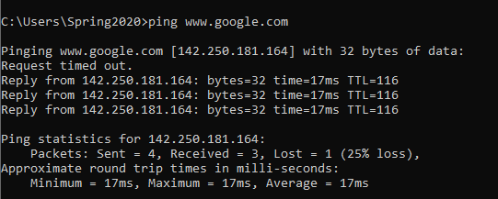

1. tracert [www.yahoo.com](http://www.yahoo.com)

1. ping -i 6 www.facebook.com, did you receive the correct reply? If not, explain why.

1. nslookup www.live.com, did you result show ‘Non-authoritative answer’? If yes, explain what does it indicate, you are advised to browse the internet to attain this answer.

* Differentiate between Ping and PathPing commands.

**Ping**

Ping command is used to is used to test the network connectivity between end points, that is between source and destination. If you are getting a proper success output from the ping command the meaning is that the IPv4 datagram packet can reach up to destination IPv4 address. It works using ICMP Echo request & ICMP Echo reply message.

**Path Ping**

Path Ping can be used to test the network connectivity between end points, that is between source and destination. It can also trace the path followed by and IPv4 datagram from source to destination. But path ping command can also find the packet loss and network latency between source and destination and between network links.

* Find all Active/ Used IP addresses on your network.

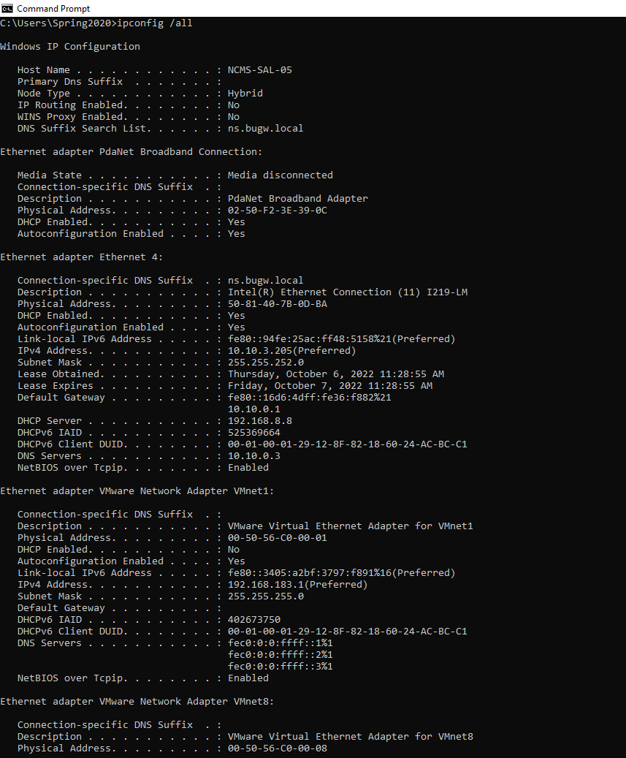

* How to verify connection with remote computer?

**Ping** command is used to verify connection with remote computer.

**NOTE:**

The commands must be run on the command prompt and clear snapshots with headings must be attached with proper numbering. Answers to the other questions must be given on a separate sheet, typed or handwritten with proper numbering. Any other formats apart from the above will not be entertained.

**TIME BOXING:**

|  |  |  |
| --- | --- | --- |
| **Activity Name** | **Activity Time** | **Total Time** |
| **Instruments Allocation + Setting up Lab** | 10 mints | 10 mints |
| **Walk through Theory & Tasks (Lecture)** | 60 mints | 60 mints |
| **Implementation & Practice time** | 90 mints | 80 mints |
| **Evaluation Time** | 20 mints | 20 mints |
|  | Total Duration | 180 mints |

**Teacher Signature**: ________________________

**Student Registration No**: ______________